**Heat Map**

|  |
| --- |
| **COMPONENT NAME** |
| **Heat Map** |
| **VERSION** |
| **1.0** |
| **AUTHOR** |
| **Yashita Goyal** |
| **WHEN WOULD I USE THIS?** |
| When business user wants to know representation of data in the form of a map in which data values are represented as colors. The spread of the his/her customer details in terms of like Number of Account in particular country with number of employees in each state. |
| **INSTALLATION & DEPENDENCIES** |
| **Package Name:** [Lightning Heat Map Component](https://yashita-goyal-unmanage-dev-ed.my.salesforce.com/0337F000000PfoY?tab=PackageComponents)  **Build URL:**[*https://login.salesforce.com/packaging/installPackage.apexp?p0=04t7F000001dBdi*](https://login.salesforce.com/packaging/installPackage.apexp?p0=04t7F000001dBdi)  To make the component usable just create Lightning tab and select component named as ‘***c: HeatMapBinding***’.   * **Filter Component** – Used to provide Filter and button * **Map Component** – Used to show selected filter criteria result * **Binding Component** – Contains Filter and Map component and a field to show count of records |
| **POST INSTALLATION STEPS** |
| * Activate or create Data Integration Rules for object Account, Contact, Lead. On basis of address it gets latitude longitude field value * Install Heat Map Component package * Create records for Custom Metadata type as: * For Custom Metadata Type Name: **Heat Map VF URL**   + Label: Page URL   + Heat Map VF URL Name: Page_URL   + VF Page URL: <Preview HeatMapVFPage and take the domain name of VF page>.   **Example**: If preview URL is: <https://XXX-unmanage-dev-ed--c.ap5.visual.force.com/apex/HeatMapVFPage>  VF Page URL field will have: XXX-unmanage-dev-ed--c.ap5.visual.force.com   * For Custom Metadata Type Name: **Heat Map Object Setup**   + Label: Object Name 1   + Heat Map Object Setup Name: Object_Name_1   + Object Name: Account   + Label: Object Name 2   + Heat Map Object Setup Name: Object_Name_2   + Object Name: Contact   + Label: Object Name 3   + Heat Map Object Setup Name: Object_Name_3   + Object Name: Lead * Navigate to Lightning Experience * Open Heat Map Application * There is one custom Tab “Heat Map”. Fill in data for Number of Employees on Account and lead records to see result |
| **USAGE** |
| The usage of component will only be seen when administrator want to see data of all things at one place. So they can use it as a custom tab in any lightning application. |

**Screenshots:**

1. **Initially when tab is loaded**

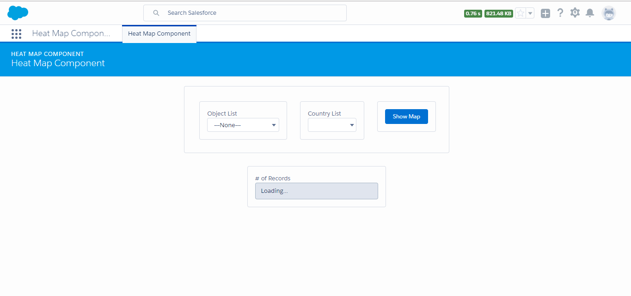

1. **When user selects object**

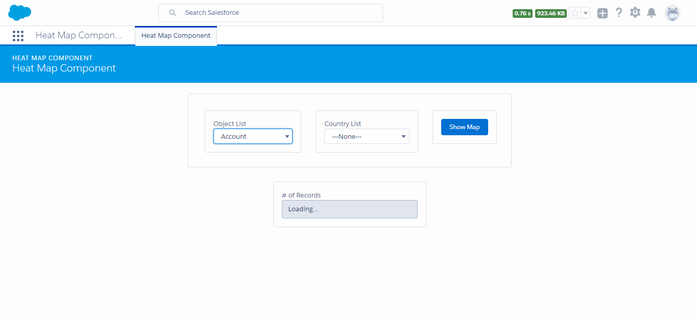

1. **Country List gets populated with respect to object selected**

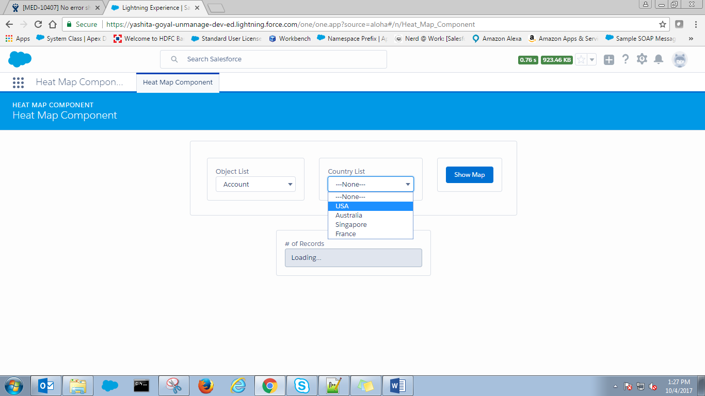

1. **On click of button “Show Map”. The field # of Records shows the count of records and below is the map**

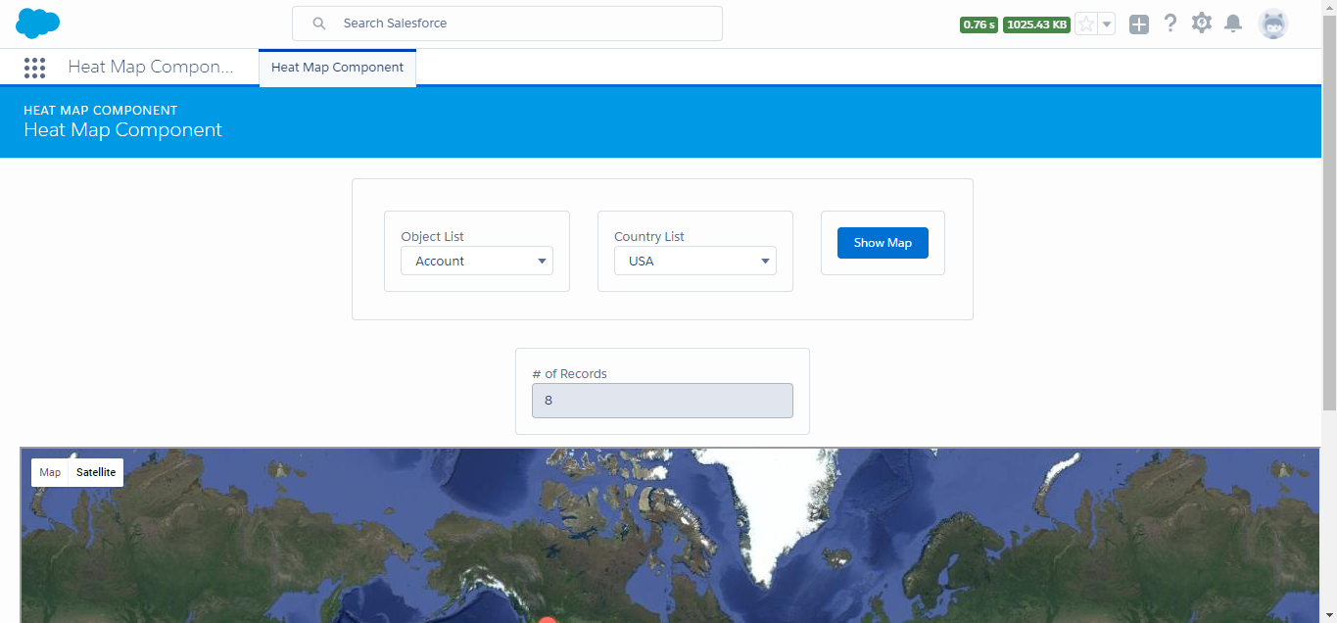

**On click of marker it shows the detail as below**

